

Multivariate Linear Analysis Assignment 1

Eoin Gallagher

08/11/2023

—

STU

—

Arthur White

Abstract

We analysed a data set MichelinNY.csv which contains data containing French Michelin Star restaurants in New York with some non-Michelin Star restaurants. We hypothesized that the Michelin Star restaurants performed better on average than the normal restaurants of New York. Our basis for grading these restaurants came from the Zagat Survey which contained 164 restaurants, 74 being Michelin Star restaurants and 90 being normal restaurants. It was found that Michelin Star restaurants performed better under every metric, which included Food, Décor, and Service. However, the price metric of Michelin Star restaurants was larger by a great margin. Through Principal Component Analysis (PCA) we saw that Food and Service were the highest performing metrics for Michelin Star restaurants however for normal restaurants it was Price and Service which performed best. Michelin Star restaurants had a more even spread of quality across the board with normal restaurants having a much larger range in values. The Michelin Star restaurants formed distinct clusters and showed strong similarities within our cluster analysis. The non-Michelin Star restaurants showed much larger dissimilarity than Michelin Star restaurants and formed clusters at a much larger distance to one another. Michelin Star restaurants performed better on average than normal restaurants of New York according to the Zagat Survey.

Introduction

In this report, we analysed 164 different French restaurants of New York, which are contained in the Zagat Survey, with 74 being included in the Michelin Guide. The Michelin Guide is a series of books produced by the Michelin company which awards stars to different restaurants depending on their quality of experience. The Zagat Survey is a well-known organization which collects and correlates the ratings of restaurants by diners. Though not as prestigious as a Michelin Star, The Zagat Survey may shed some insight into whether the common person shares the same opinion as a Michelin Star critic. The four qualities the Zagat Survey grade a restaurant on are Food, Décor, Service, and Price. They scale Food, Décor, and Service on a scale of 1-30, and Price is on its own independent scale with a high of 201 and low of 13. In this report we checked to see if the Michelin Star restaurants do have this high-quality gap from normal restaurants. We also checked to see if they are of similar quality between many of the restaurants and what they prioritised out of the metrics. This was completed by checking the correlations between metrics and the mean increase across these metrics we perform a Principal Component Analysis (PCA) of the data. A Hierarchical Cluster Analysis (HCA) of this data was also performed to check dissimilarity between the restaurant types.

Methods

The metrics of Food, Décor, Service, and Price were analysed by their correlations between each other, and their means were acquired to check the difference between Michelin and non-Michelin restaurants. A pairs plot was used to compare correlations and view trends. A Principal Component Analysis (PCA) was applied to the data set for both types of restaurants. All metrics were scaled accordingly using R’s built in function which implies z-score scaling to prep for PCA. This scaling method ensures that all variables have mean of 0 and standard deviation of 1, giving all variables equal importance. The percentage difference in range of values observed was recorded along with the difference in significance of each metric. This was followed by a Hierarchical Cluster Analysis (HCA) of the data to check similarities in the data and to view grouping of the different restaurant types. We standardized the data before continuing with HCA. We also created a dissimilarity matrix using Euclidean dissimilarity. Two types of HCA were used, Complete linkage method and Average linkage method. These were used as we wanted to form spherical clusters which clearly showed the similarities between data in clusters. Two dendrograms were formed using the data and the percentage of each restaurant type in each cluster was recorded. This was then used to form a tanglegram to compare the methods of Complete and Average linkage and see if they agree. The entanglement was recorded to check if the tanglegrams agreed. All statistical analyses were performed using RStudio (version RStudio 2023.06.2+561). The following R-packages were used: khroma, dendextend.

Results

Data Visualisation

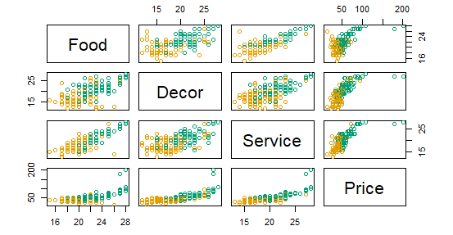
The data set MichelinNY.csv was divided into 6 columns with 164 rows. The first column was a binary input, representing the inclusion or exclusion of a restaurant in the Michelin Guide. Next were the respective names of the restaurants, followed by the metrics. The Michelin Star restaurants averaged higher quality in the metrics Food, Décor, and Service, with a mean that was 18% larger than normal restaurants. The Price of Michelin Star restaurants were 51% higher than that of normal restaurants. We used a pairs plot to plot all metrics against each other and we saw trends of high correlation across all metrics.
Figure 1: Pairs plot of values of Michelin Star restaurants (Green) vs non-Michelin Star restaurants (Orange)

The largest correlation for Michelin Star restaurants was observed between Food and Service which came to a value of 0.9. The highest correlation among the non-Michelin Star restaurants was between Décor and Price which was 0.66. We can see that there is less of a positive trend with the normal restaurants and that the values have a more random spread compared to that of the Michelin Star restaurants. We can see across all plots that the values for the Michelin Star restaurants are visually higher than that of normal restaurants as the data shows.

Principal Component Analysis (PCA)

In the PCA of the data set the first principal component covered 78% and 60% proportion of the Michelin Star restaurants and non-Michelin Star restaurants respectively, so we only focus on the first principle component in each case. We saw that there was an even spread across all metrics with the largest being Service at 0.53. There was a range of 0.07 between Service and Décor. However, in the normal restaurants we saw that there was a much larger spread with the largest metric being Price at 0.55, meaning normal restaurants charge more for less quality of service. The range of the PCA for non-Michelin restaurants was 0.15 which is 47% larger than the range of Michelin Star restaurants, showing much larger variation in the quality of the metrics.
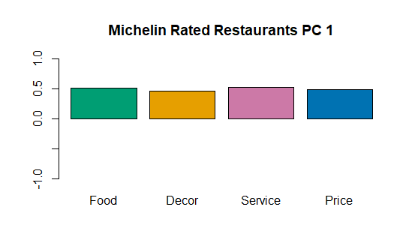
Figure 2: PCA plot showing the weight of each metric
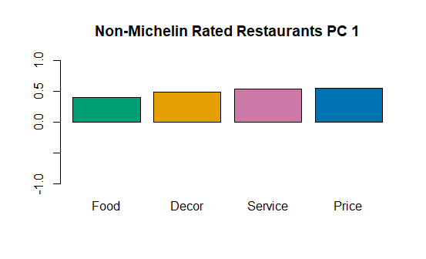

Hierarchical Cluster Analysis (HCA)

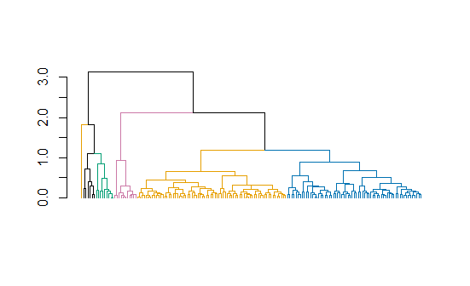
There was very clear and concise grouping of the data in our dendrogram using Euclidean dissimilarity and complete linkage. We formed six clusters as seen in Figure 3, with each colour corresponding to a different cluster. In the six clusters, we saw a large density of Michelin Star restaurants in the Pink and Yellow clusters holding 91% and 60% Michelin Star restaurants respectively. This shows the large similarity between Michelin Star restaurants experience. There was a collection of normal restaurants either side of the clusters of Michelin Star restaurants, showing large dissimilarity between these restaurants.
Figure 3: Dendrogram of Euclidean dissimilarity with Complete linkage method.

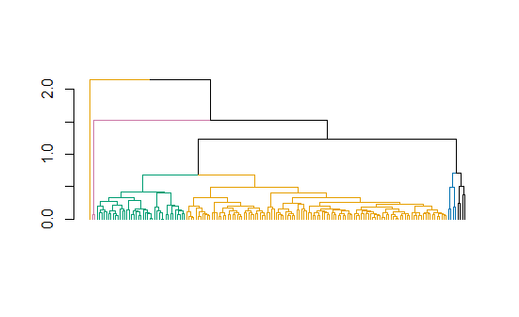
This result is also prevalent in the average dendrogram as seen in Figure 4. Again, we have 6 clusters with the Michelin Star restaurants showing high density within our Pink and Yellow clusters with 100%, and 55% Michelin Star restaurants present. This dendrogram however does not show the same similarity as the Pink and Yellow clusters are separated by the Green which only has 21% density in Michelin Star restaurants.
Figure 4: Dendrogram of Euclidean dissimilarity with Average linkage method
Again, the normal restaurants are divided by the Michelin Star restaurants, showing the dissimilarities between the restaurants. The Michelin Star restaurants have less prevalent similarity in this dendrogram but are far stronger related than the non-Michelin Star restaurants, which have 75% density in the Green cluster and have 100% and 75% density within the Blue and Black clusters respectively.

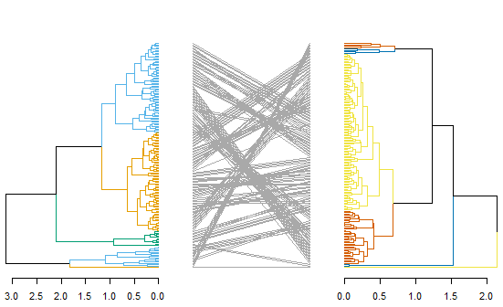
We made a comparison between the two dendrograms using a tanglegram to see if they agreed. Within this tanglegram, we could see some cross-over and entanglement, but the majority of the clusters moved in similar patterns. We had a low entanglement value of 0.226, which suggests that the dendrograms agree and provide similar results. This further reinforces the previous results found in both dendrograms.
Figure 5: Tanglegram of our dendrograms in Figure 4 & 5

Discussion

In our analysis of the Michelin data set we found that the Michelin Star restaurants outperformed the normal restaurants in every metric according to the Zagat Survey. They averaged better quality Food, Décor, Service, and there was a stronger positive correlation between these metrics. Although the Michelin Star restaurants were more expensive by a large margin, they also provided better value for money according to our principal component analysis. We found that the normal restaurants prioritized Price and the quality of food lacked behind according to our principal component analysis. We saw an across-the-board high-quality experience from the Michelin data set whereas the normal restaurants had larger dissimilarity among results and did not have any guarantee on the experience provided.

The Michelin Star restaurants were very similar in quality, and they provide a similar experience as shown by the hierarchical clustering methods used. In the first dendrogram using Euclidean dissimilarity and complete linkage there are definite clusters which are dense in Michelin Star restaurants. These clusters separate the normal restaurants, showing the large dissimilarities between them. In the second dendrogram using Euclidean dissimilarity and average linkage there is also definite clusters with the clusters being slightly less dense in Michelin Star restaurants and having more of a spread among the clusters. However, it was still concise with groupings of Michelin Star restaurants and showed high similarity between the restaurants. The tanglegram then states that our dendrograms agree with a small entanglement value of 0.226. This confirms both dendrograms come to the same decision that the Michelin Star restaurants have high similarity.

The aim of our analysis was to verify if these French Michelin Star restaurants were far greater than the non-Michelin Star restaurants using the Zagat Survey as a basis for our analysis. In summary, we found that the Michelin Star restaurants greatly outperformed the majority of normal restaurants within our data set and lived up to the high reputation that the Michelin Guide holds. The Michelin Star restaurants were far more expensive on average than the normal restaurants and, but the quality of service justifies this statistic. There is potential to follow up this analysis by doing a larger study with a larger data set or using a different basis to the Zagat Survey. The Michelin Guide appears to be a good measure at this point in time for the quality of experience provided by a restaurant.

